* Indicate whether each of the following is a question of fact, a question of value or a question of policy.
* 1. What should we do to increase the quality of financial parts?
* 2. Do police stop African American drivers more frequently than others drivers?
* 3. Should television news organization use exit polls to call elections?
* 4. Is john guilty of manslaughter?
* 5. what is the best vacation plan for our family?

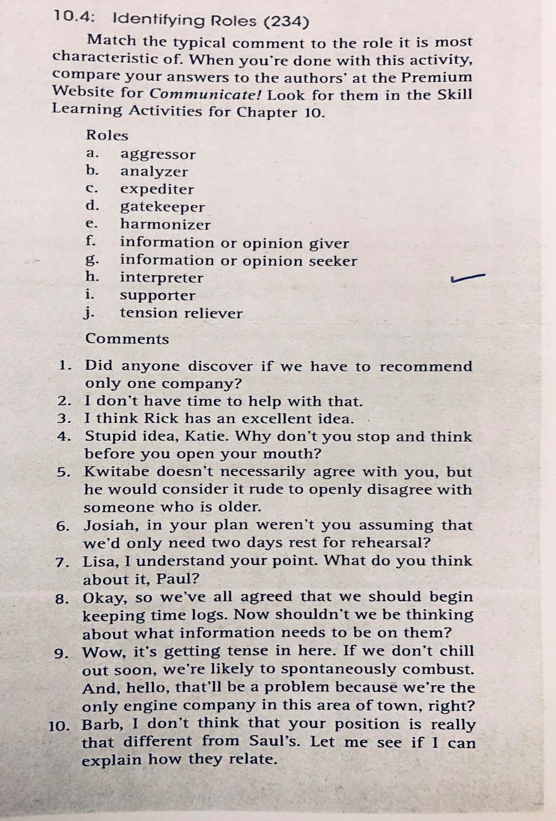

a.

b.

c.

d.

e

f.

g.

h.

i.

j